# 8 Groups and Teams

How Can Working with Others Increase Everybody’s Performance?

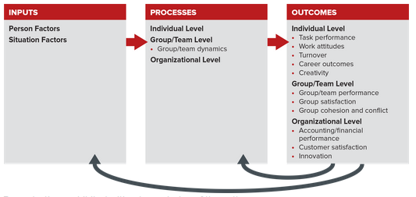

## 8.1 Group Characteristics,

Drawing from the field of sociology, we define a group as (1) two or more freely interacting individuals who (2) share norms and (3) goals and (4) have a common identity. These criteria are illustrated in Figure 8.2. Think of the various groups to which you belong. Does each group satisfy the four criteria in our definition?

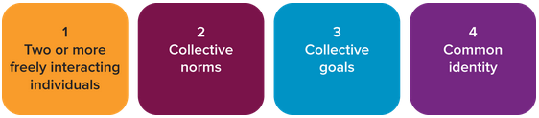

A group is different from a crowd or organization. Here is how organizational psychologist E. H. Schein helps make the distinctions clear:

The size of a group is … limited by the possibilities of mutual interaction and mutual awareness. Mere aggregates of people do not fit this definition [of a group] because they do not interact and do not perceive themselves to be a group even if they are aware of each other as, for instance, a crowd on a street corner watching some event. A total department, a union, or a whole organization would not be a group in spite of thinking of themselves as “we,” because they generally do not all interact and are not all aware of each other. However, work teams, committees, subparts of departments, cliques, and various other informal associations among organizational members would fit this definition of a group.

The size of a group is thus limited by the potential for mutual interaction and mutual awareness. People form groups for many reasons. Most fundamental is that groups usually accomplish more than individuals. It seems, for instance, that simply interacting with others improves both individual and team accuracy.

Formal and Informal Groups,

Individuals join or are assigned to groups for various purposes. A formal group is assigned by an organization or its managers to accomplish specific goals. Such groups often have labels: work group, team, committee, or task force. An informal group exists when the members’ overriding purpose in getting together is friendship or a common interest. Formal and informal groups often overlap, such as when a team of analysts plays tennis after work.

Functions of Formal Groups,

Formal groups fulfill two basic functions: organizational and individual (see Table 8.1). Complex combinations of these functions can be found in formal groups at any given time.

Roles and Norms: The Social Building Blocks of Group and Organizational Behavior,

Groups transform individuals into functioning organizational members through subtle yet powerful social forces. These social forces, in effect, turn “I” into “we” and “me” into “us.” Group influence weaves individuals into the organization’s social fabric by communicating and enforcing both role expectations and norms. That is, group members positively reinforce those who adhere to roles and norms with friendship and acceptance. However, nonconformists experience criticism and even ostracism or rejection by group members. Anyone who has experienced the “silent treatment” from a group of friends knows what a potent social weapon ostracism can be. Let’s look at how roles and norms develop and why they are enforced.

What Are Roles and Why Do They Matter?

A role is a set of expected behaviors for a particular position, and a group role is a set of expected behaviors for members of the group as a whole. Each role you play is defined in part by the expectations of that role. As a student, you are expected to be motivated to learn, conscientious, participative, and attentive. Professors are expected to be knowledgeable, prepared, and genuinely interested in student learning. Sociologists view roles and their associated expectations as a fundamental basis of human interaction and experience.

Two types of roles are particularly important, task and maintenance. Effective groups ensure that both are being fulfilled (see Table 8.2). Task roles enable the work group to define, clarify, and pursue a common purpose, and maintenance roles foster supportive and constructive interpersonal relationships. Task roles keep the group on track, while maintenance roles keep the group together. Members can play more than one role at a time, or over time.

Task Roles,Description.

Initiator, Suggests new goals or ideas.

Information seeker/giver, Clarifies key issues.

Opinion seeker/giver, Clarifies pertinent values.

Elaborator, Promotes greater understanding through examples or exploration of implications.

Coordinator, Pulls together ideas and suggestions.

Orienter, Keeps group headed toward its stated goal(s).

Evaluator, Tests group’s accomplishments with various criteria such as logic and practicality.

Energizer, Prods group to move along or to accomplish more.

Procedural technician, performs routine duties (handing out materials or rearranging seats).

Recorder, Performs a “group memory” function by documenting discussion and outcomes.

Maintenance Roles, Description.

Encourager, Fosters group solidarity by accepting and praising various points of view.

Harmonizer, Mediates conflict through reconciliation or humor.

Compromiser, Helps resolve conflict by meeting others halfway.

Gatekeeper, Encourages all group members to participate.

Standard setter, Evaluates the quality of group processes.

Commentator, Records and comments on group processes/dynamics.

Follower, Serves as a passive audience.

What Are Norms and Why Do They Matter?

“A norm is an attitude, opinion, feeling, or action, shared by two or more people, that guides behavior.”13 Norms help create order and allow groups to function more efficiently because they save groups from having to figure out how to do the same things each time they meet. Norms also help groups move through the development process. Can you imagine having to establish guidelines over and over again?

Norms are more encompassing than roles, which tend to be at the individual level in the Organizing Framework and pertain to a specific job or situation. Norms, in contrast, are shared and apply to the group, team, or organization.

Norm , “Make our department look good in top management’s eyes.” , Reason , Group/organization survival , Example of reinforcement, A staff specialist vigorously defends the vital role of her department at a divisional meeting and is later complimented by her boss.

Norm , “Work hard and don’t make waves.” , Reason , Clarification of behavioral expectations , Example of reinforcement, A senior manager takes a young associate aside and cautions him to be a bit more patient with coworkers who see things differently.

Norm , “Be a team player, not a star.” , Reason , Avoidance of embarrassment , Example of reinforcement, A project team member is ridiculed by her peers for dominating the discussion during a progress report to top management.

Norm , “Make customer service our top priority.” , Reason , Clarification of central values , Example of reinforcement, Two sales representatives are given a surprise Friday afternoon party for winning best-in-the-industry customer service awards from an industry association.

## 8.2 The Group Development Process.

Tuckman’s Five-Stage Model of Group Development,

Tuckman’s five-stage model of group development, forming, storming, norming, performing, adjourning, has great practical appeal because it is easy to remember and apply. Notice in the top part of Figure 8.3 how individuals give up an increasing amount of their independence as a group develops. The lower box of the figure also describes some of the issues faced by individual members and the larger group as it develops.

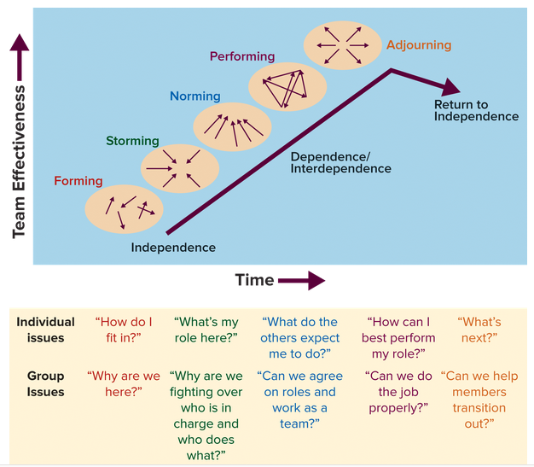

Stage 1: Forming,

During the ice-breaking forming stage, group members tend to be uncertain and anxious about such unknowns as their roles, the people in charge, and the group’s goals. Mutual trust is low, and there is a good deal of holding back to see who takes charge and how.

Stage 2: Storming,

The storming stage is a time of testing. Individuals test the leader’s policies and assumptions as they try to decide how they fit into the power structure. Subgroups may form and resist the current direction of a leader or another subgroup. In fact, some management experts say the reason many new CEOs don’t survive is that they never get beyond the storming stage. For instance, Ron Johnson joined JCPenney after leaving Apple, and he never convinced employees and top managers to accept his radical rebranding of the aging retailer. As CEO he fired thousands of employees, and much of the old guard, but many of those who remained resisted his plan, as did the board of directors. Marissa Mayer has had a similar experience at Yahoo. She took the helm of a struggling company, changed strategies, fired thousands, and never really gained support from important stakeholders, such as investors, industry partners, and the remaining employees. Many groups stall in Stage 2 because of the way the use of power and politics can erupt into open rebellion.

Stage 3: Norming,

Groups that make it through Stage 2 generally do so because a respected member, other than the leader, challenges the group to resolve its power struggles so work can be accomplished. Questions about authority and power are best resolved through unemotional, matter-of-fact group discussion. A feeling of team spirit is sometimes experienced during this stage because members believe they have found their proper roles. Group cohesiveness, defined as the “we feeling” that binds members of a group together, is the principal by-product of Stage 3.

Stage 4: Performing,

Activity during this vital stage is focused on solving task problems, as contributors get their work done without hampering others. This stage is often characterized by a climate of open communication, strong cooperation, and lots of helping behavior. Conflicts and job boundary disputes are handled constructively and efficiently. Cohesiveness and personal commitment to group goals help the group achieve more than could any one individual acting alone.

Stage 5: Adjourning,

The group’s work is done; it is time to move on to other things. The return to independence can be eased by rituals such as parties and award ceremonies celebrating the end and new beginnings. During the adjourning stage, leaders need to emphasize valuable lessons learned.

Punctuated Equilibrium,

In contrast to the discrete stages of Tuckman’s model, some groups follow a form of development called punctuated equilibrium. Groups establish periods of stable functioning until an event causes a dramatic change in norms, roles, and/or objectives. The group then establishes and maintains new norms of functioning, returning to equilibrium (see Figure 8.4). Extreme examples of punctuated equilibrium often occur because of disruptive technologies, such as Apple’s introduction of iTunes. This innovation caused all players in the music industry to radically change their approaches from digital to streaming and from purchasing entire albums to buying individual songs and subscriptions. Walmart’s low-price approach to big-box retailing also revolutionized an industry. In such scenarios companies and teams that can adapt will realize tremendous new opportunities, but those that don’t often find themselves obsolete and go out of business. This phenomenon plays out at all levels of OB. Many individual’s careers have been ignited due to punctuated equilibrium. This means that punctuated equilibrium at the organizational level drives significant change, development, and opportunity at the group and individual levels too. Apply your new knowledge of OB to be sure your career is one of them.

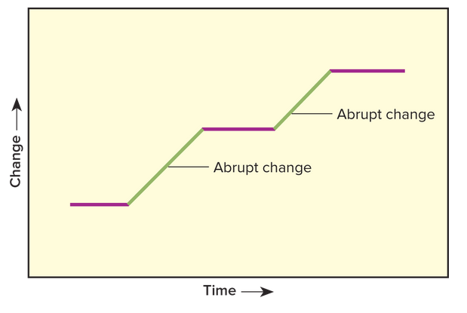

## 8.3 Teams and the Power of Common Purpose,

A team is a small number of people who are committed to a common purpose, performance goals, and approach for which they hold themselves collectively accountable. Besides being a central component of the Organizing Framework, teams are a cornerstone of work life. General Electric CEO Jeffrey Immelt offers this blunt overview:

A Team Is More than Just a Group,

Management consultants at McKinsey & Co. say it is a mistake to use the terms group and team interchangeably. After studying many different kinds of teams, from athletic to corporate to military, they concluded that successful teams tend to take on a life of their own. A group becomes a team when it meets the criteria in Table 8.4.

Evaluating Teamwork Competencies

There are at least two ways to use Table 8.5 and your knowledge of teamwork competencies. The first is as tools to enhance your self-awareness. The second is as a means to measure your performance and that of other members of your team. Self-Assessment 8.3 can be useful for both.

What Does It Mean to Be a Team Player?

Understanding and exhibiting the competencies noted in Table 8.5 is an excellent start on becoming a team player. And while everybody has her or his own ideas of the characteristics that are most important, most people likely include the three Cs of team players:

Committed, Collaborative, Competent,

What Is Social Loafing?

Social loafing is the tendency for individual effort to decline as group size increases. To illustrate the point, consider a group or team of which you’re a member and ask yourself: “Is group performance less than, equal to, or greater than the sum of its parts?” Can three people working together, for example, accomplish less than, the same as, or more than they would working separately? A study conducted more than a half-century ago found the answer to be less than. In a tug-of-war exercise, three people pulling together achieved only two-and-a-half times the average individual rate. Eight pullers achieved less than four times the individual rate.

Social loafing is problematic because it typically consists of more than simply slacking off. Free riders (loafers) not only produce low-quality work, which causes others to work harder to compensate, but they often also distract or disrupt the work of other team members. And they often expect the same rewards as those who do their work. You undoubtedly have many examples from your own experiences. Given social loafing is so common and problematic, let’s look at how to guard against it.

Limit group size.

Ensure equity of effort to reduce the possibility that a member can say, “Everyone else is goofing off, so why shouldn’t I?”

Hold people accountable. Don’t allow members to feel they are lost in the crowd and can think, “Who cares?”

Cross-Functional Teams

Cross-functional teams are created with members from different disciplines within an organization, such as finance, operations, and R&D. Cross-functional teams can be used for any purpose, they can be work or project teams, and they may have a short or indefinite duration. New-product development is an area in which many organizations utilize cross-functional teams. Brian Walker, CEO of furniture maker Herman Miller, described how the company uses cross-functional teams to leverage the talents of employees in product development and boost company performance:

Self-Managed Teams

Self-managed teams are groups of workers who have administrative oversight over their work domains. Administrative oversight consists of activities such as planning, scheduling, monitoring, and staffing. These are normally performed by managers, but in self-managed teams employees act as their own supervisors. Self-managed teams have a defined purpose and their duration can vary, along with the level of member commitment. Cross-functional, work, and project teams can all be self-managed.

Self-managed does not mean workers are simply turned loose to do their own thing. Indeed, an organization embracing self-managed teams should be prepared to undergo revolutionary changes in its management philosophy, structure, staffing and training practices, and reward systems. Managers sometimes resist self-managed teams, due to the perceived threat to their authority and job security.

Virtual Teams,

Virtual teams work together over time and distance via electronic media to combine effort and achieve common goals. Traditional team meetings are location-specific. You and other team members are either physically present or absent. Members of virtual teams, in contrast, report in from different locations, different organizations, and often different time zones and countries.

Best Uses of Virtual Teams

Virtual teams and distributed workers present many potential benefits: reduced real estate costs (limited or no office space); ability to leverage diverse knowledge, skills, and experience across geography and time (you don’t have to have an SAP expert in every office); ability to share knowledge of diverse markets; and reduced commuting and travel expenses. The flexibility often afforded by virtual teams also can reduce work–life conflicts for employees, which some employers contend makes it easier for them to attract and retain talent.

Obstacles for Virtual Teams

Virtual teams have challenges, too. It is more difficult for them than for face-to-face teams to establish team cohesion, work satisfaction, trust, cooperative behavior, and commitment to team goals. Many of these are important elements in the Organizing Framework. So virtual teams should be used with caution. It should be no surprise that building team relationships is more difficult when members are geographically distributed. This hurdle and time zone differences are challenges reported by nearly 50 percent of companies using virtual teams. Members of virtual teams also reported being unable to observe the nonverbal cues of other members and a lack of collegiality. These challenges apply to virtual teams more generally, as does the difficulty of leading such teams. When virtual teams cross country borders, cultural differences, holidays, and local laws and customs also can cause problems.

Effective Virtual Team Participation and Management

We put together a collection of best practices to help focus your efforts and accelerate your success as a member or leader of a virtual team:

1. Adapt your communications. Learn how the various remote workers function, including their preferences for e-mail, texts, and phone calls. It often is advisable to have regularly scheduled calls (via Skype). Be strategic and talk to the right people at the right times about the right topics. Don’t just blanket everybody via e-mail, focus your message. Accommodate the different time zones in a fair and consistent manner.
2. Share the love. Use your company’s intranet or other technology to keep distributed workers in the loop. Acknowledging birthdays and recognizing accomplishments are especially important for those who are not regularly in the office. Newsletters also can help and serve as a touch point and vehicle for communicating best practices and success stories.
3. Develop productive relationships with key people on the team. This may require extra attention, communication, and travel, but do what it takes. Key people are the ones you can lean on and the ones who will make or break the team assignment.
4. Be a good partner. Often members of virtual teams are not direct employees of your employer but are independent contractors. Nevertheless, your success and that of your team depend on them. Treat them like true partners and not hired help. You need them and presumably they need you.
5. Be available. Managers and remote workers all need to know when people can be reached, where, and how. Let people know and make yourself available.
6. Document the work. Because of different time zones, some projects can receive attention around the clock, as they are handed off from one zone to the next. Doing this effectively requires that both senders and receivers clearly specify what they have completed and what they need in each transfer.
7. Provide updates. Even if you are not the boss, or your boss doesn’t ask for them, be sure to provide regular updates on your progress to the necessary team members.
8. Select the right people. Effective virtual workers generally prefer and do well in interdependent work relationships. They also tend to be self starters and willing to take initiative. Such independent thought contrasts starkly with people who prefer to wait for instructions before taking action.
9. Use your communication skills. Because so much communication is written, virtual team members must have excellent communication skills and write well in easy-to-understand and to-the-point language.

Face Time,

Researchers and consultants agree about one aspect of virtual teams, there is no substitute for face-to-face contact. Meeting in person is especially beneficial early in virtual team development, and team leaders are encouraged to meet even more frequently with key members. Face-to-face interactions can be as simple as lunch, water-cooler conversations, social events, or periodic meetings. Whatever the case, such interactions enable people to get familiar with each other and build credibility, trust, and understanding. This reduces misunderstandings and makes subsequent virtual interactions more efficient and effective, and it also increases job performance and reduces conflict and intentions to quit.

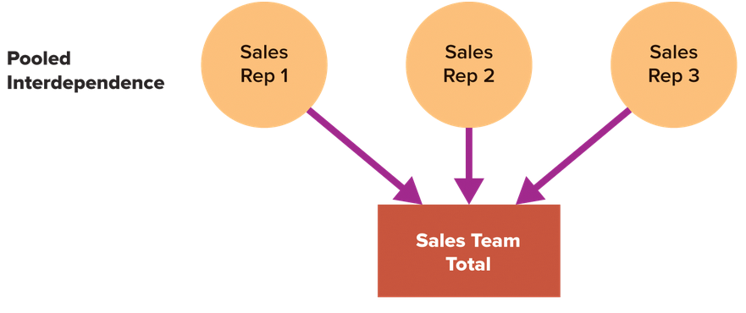

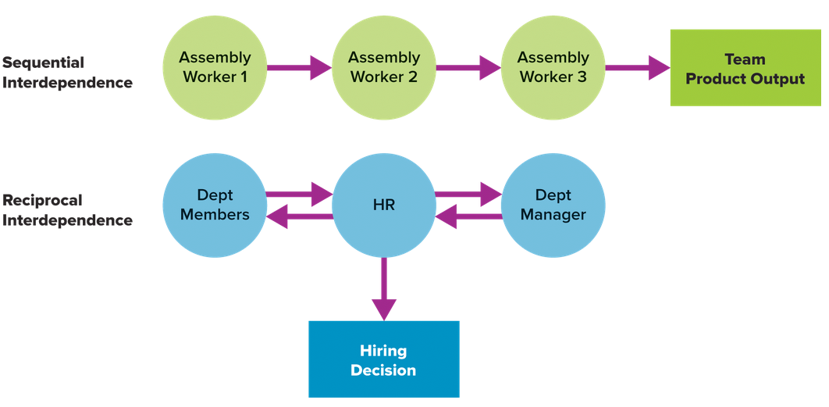

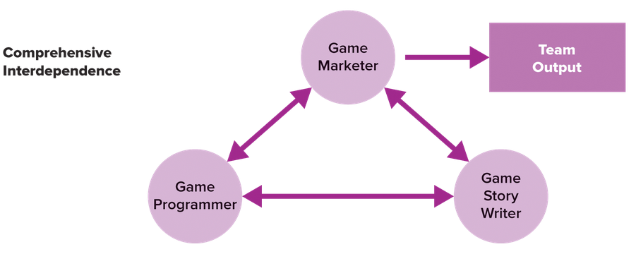

## 8.4 Trust Building and Repair, Essential Tools for Success,

Trust is the willingness to be vulnerable to another person, and the belief that the other person will consider the impact of how his or her intentions and behaviors will affect you. We can hardly overstate the value of trust in organizational life. Only respectful treatment was rated higher as a predictor of employee job satisfaction,53 and many would see trust and respect as highly correlated.

Trust is the lubricant of interpersonal relationships within and between all organizational levels in the Organizing Framework, and thus it also drives performance across levels (see Figure 8.6). Lack of trust, for example, is a key factor in employee turnover. One study found that 59 percent of employees quit their jobs due to trust issues, which were linked to a lack of leader communication and honesty. Trust within groups of hospitality employees was also associated with increased motivation and performance.

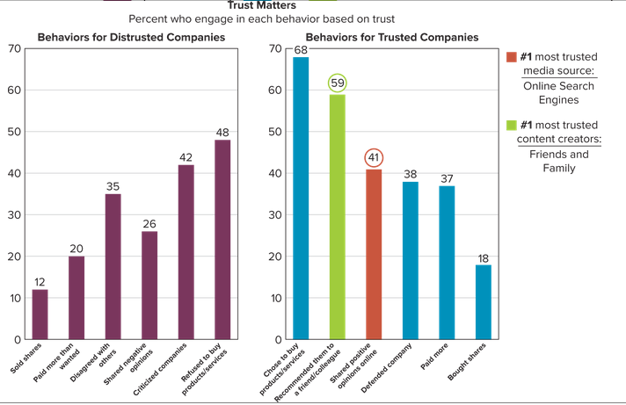

Three Forms of Trust

For our purposes in OB, we discuss three particular forms of trust:

1. Contractual trust. Trust of character. Do people do what they say they are going to do? Do managers and employees make clear what they expect of one another?
2. Communication trust. Trust of disclosure. How well do people share information and tell the truth?
3. Competence trust. Trust of capability. How effectively do people meet or perform their responsibilities and acknowledge other people’s skills and abilities?

Building Trust,

You may already believe that to get trust you must give trust. The practical application of this view, and of new knowledge we’ve gained about trust, is to act in ways that demonstrate each of the three types of trust. Doing so builds trust. You can also benefit by practicing the following behaviors for building and maintaining trust:

Communication. Keep team members and employees informed by explaining policies and decisions and providing accurate feedback. Be candid about your own problems and limitations. Tell the truth.

Support. Be available and approachable. Provide help, advice, coaching, and support for team members’ ideas.

Respect. Delegation, in the form of real decision-making authority, is the most important expression of managerial respect. Delegating meaningful responsibilities to somebody shows trust in him or her. Actively listening to the ideas of others is a close second.

Fairness. Be quick to give credit and recognition to those who deserve it. Make sure all performance appraisals and evaluations are objective and impartial.

Predictability. Be consistent and predictable in your daily affairs. Keep both expressed and implied promises.

Competence. Enhance your credibility by demonstrating good business sense, technical ability, and professionalism.

Repairing Trust,

Regardless of who is responsible for eroding or damaging trust, both parties need to be active in the repair of trust. Dennis and Michelle Reina studied thousands of instances of broken trust in business and developed seven steps for regaining it. Figure 8.7 illustrates their recommendations as an upward staircase, to show how individuals must work their way back from distrust, one step at a time, to finally regain what they have lost. This seven-step process can help whether you are the perpetrator or the victim.

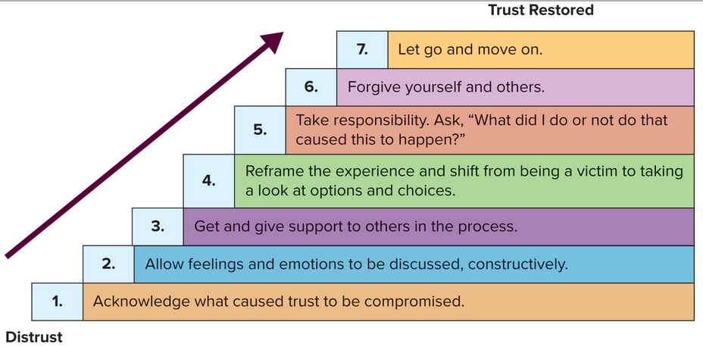

## 8.5 Keys to Team Effectiveness,

Characteristics of High-Performing Teams,

Current research and practice have identified the following eight attributes of high-performance teams:

1. Shared leadership, interdependence created by empowering, freeing up, and serving others.
2. Strong sense of accountability, an environment in which all team members feel as responsible as the manager for the performance of the work unit.
3. Alignment on purpose, a sense of common purpose about why the team exists and the function it serves.
4. Open communication, a climate of open and honest communication.
5. High trust, belief that member actions and intentions focus on what’s best for the team and its members.
6. Clear role and operational expectations, defined individual member responsibilities and team processes.
7. Early conflict resolution, resolution of conflicts as they arise, rather than avoidance or delay.
8. Collaboration, cooperative effort to achieve team goals.

The 3 Cs of Effective Teams,

With the above characteristics in mind, you might ask: How do you build a high-performing team? The short answer is to use the three Cs. (Note: These three Cs are at the team level, in contrast to the three Cs of effective team players discussed earlier that focus on the individual or team member level.) The three Cs are:

1. Charters and strategies,
2. Composition,
3. Capacity

Charters and Strategies,

Both researchers and practitioners urge groups and teams to plan before tackling their tasks, early in the group development process (the storming stage). These plans should include team charters that describe how the team will operate, such as through processes for sharing information and decision making (teamwork). Team charters were discussed in the Winning at Work feature at the beginning of this chapter. Teams should also create and implement team performance strategies, deliberate plans that outline what exactly the team is to do, such as goal setting and defining particular member roles, tasks, and responsibilities.

Composition,

Team composition describes the collection of jobs, personalities, knowledge, skills, abilities, and experience levels of team members. When we think of it this way, it is no surprise that team composition can and does affect team performance. Team member characteristics should fit the responsibilities of the team if the team is to be effective. Fit facilitates effectiveness and misfit impedes it, you need the right people on your team.

Capacity,

Team adaptive capacity (adaptability) is the ability to make needed changes in response to demands put on the team. It is fostered by team members who are both willing and able to adapt to achieve the team’s objectives. Described in this way, team adaptive capacity is a matter of team composition, the characteristics of individual team members. And it is an input in the Organizing Framework that influences team-level outcomes.

Collaboration and Team Rewards,

Collaboration is the act of sharing information and coordinating efforts to achieve a collective outcome. It’s safe to assume that teams whose members collaborate are more effective than those whose members don’t. Collaboration is what enables teams to produce more than the sum of their parts. Many factors can influence collaboration, including how teams are rewarded. In this final section we’ll explore how to foster collaboration and the role rewards can play.

Collaboration, The Lifeblood of Teamwork,

As interdependence increases, so too does the need for and value of collaboration. Today’s business landscape, characterized by globalization, outsourcing, strategic partnering, and virtual teams, makes collaboration ever more important. That said, many things can interfere with collaboration. To help foster collaboration, we recommend the following as a starting point:

1. Communicate expectations. Clarifying roles and responsibilities for each team member is essential. Identify and communicate both individual and team accountability.
2. Set team goals. SMART goals for teams are a good place to start, but also review goals regularly as a team (weekly, monthly, or quarterly). Be sure individual roles and responsibilities align with team goals.
3. Encourage creativity. Create a safe environment where employees can take risks without fear of humiliation or career damage. Nurture a “can do” attitude within the team, and foster it by asking why or why not instead of saying yes or no.
4. Build work flow rhythm. Technology can be of great assistance. Project management software as well as other scheduling tools can help team members know exactly what they need to do and when. This can greatly assist in their coordination efforts and help assure that interdependent needs of team members are met.

Reward Collaboration and Teamwork,

Organizations that foster the greatest collaboration and assemble the most effective teams typically use hybrid reward systems that recognize both individual and team performance. Table 8.6 provides guidance on how to reward performance in teams, based on the desired outcome (speed or accuracy) and the degree of interdependence (low, moderate, high). These guidelines can give you a tremendous head start in determining how best to reward and motivate team performance.